**CSCE 629 Lab 1**

**Winter 2019**

**Reconnaissance / Linux / Interacting with Targets**

**Marvin Newlin**

**Assigned: Lesson 1, 3 Jan**

**Due: Lesson 7, 15 Jan, 1400**

**Part 1 - Reconnaissance**

1. Provide the name, complete email address, and phone number for the web POC at USAFA on 24 Feb 2001.

* Googled USAFA website to find that the USAFA website is <https://www.usafa.af.mil/>
* Went to the WayBackMachine https://web.archive.org/ and entered the USAFA URL in the search bar

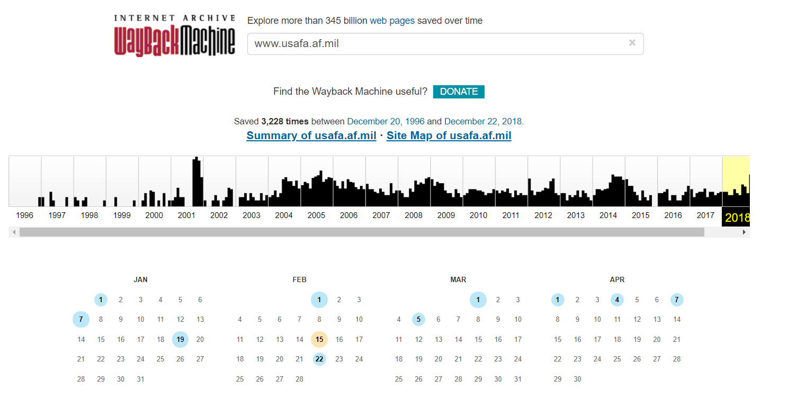

* Selected 24 Feb 2001

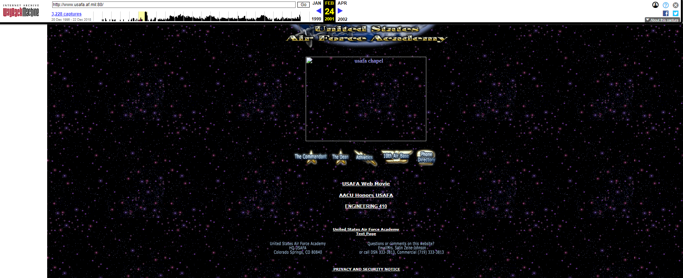

* At the bottom of the page we see the contact info for the POC at the bottom of the page

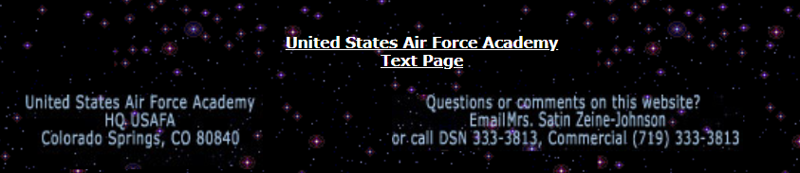

* To find her email we hover over her name

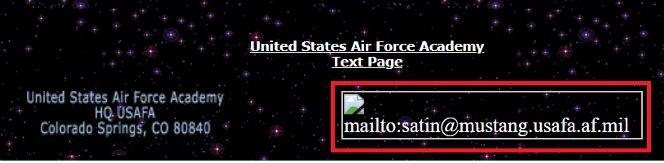

* This shows us the info for the Web POC on 24 Feb 01 was
  + Mrs. Satin Zeine-Johnson
  + (719) 333 – 3813
  + satin@mustang.usafa.af.mil

2. List the social security numbers for Kevin Mitnick. Explain how you learned this information.

* Went to [www.google.com](http://www.google.com)
* Googled “kevin Mitnick ssn”

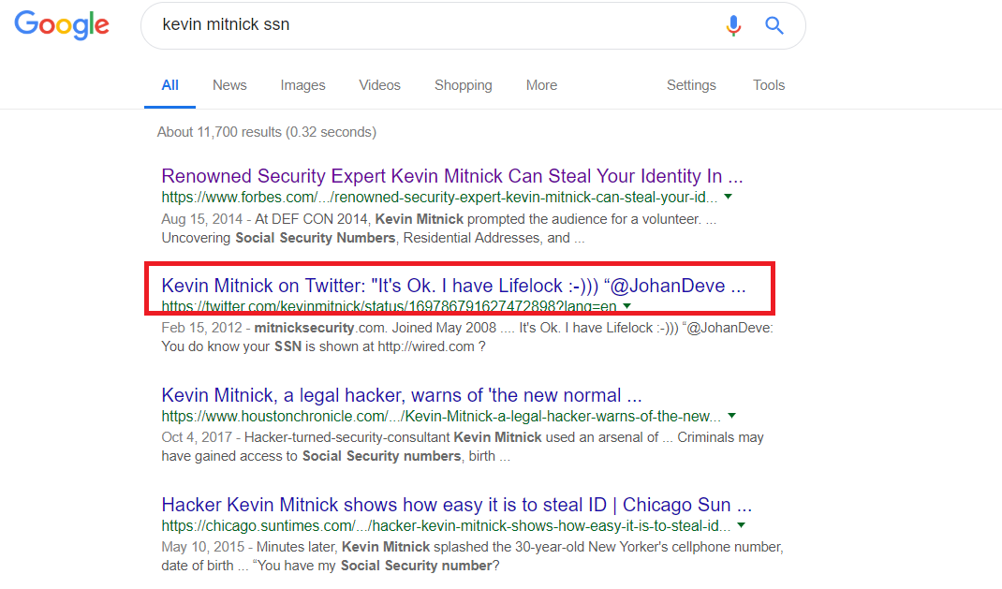

* Selected the second hit that links to <https://twitter.com/kevinmitnick/status/169786791627472898?lang=en>. Clicking this leads to the following tweet

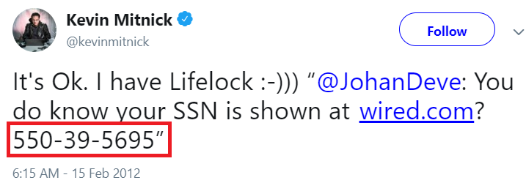

* Kevin Mitnick’s SSN is 550-39-5695 as shown in the red box

3. On the author’s (Ed Skoudis) website, what is the title of the third puzzle in the author’s “Math Puzzles” list? I am not referring to his “Hacker Challenges” list.

* Googled “Ed Skoudis Website” to find that his website is [www.counterhack.net](http://www.counterhack.net)
* Googled “ed skoudis math puzzles” and clicked the first link for the math puzzles page on his website

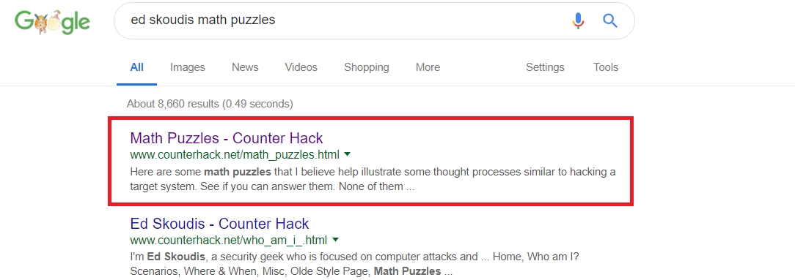

* This takes you to the Math puzzles page and the third puzzle is “Island of the Blue-Eyed People”

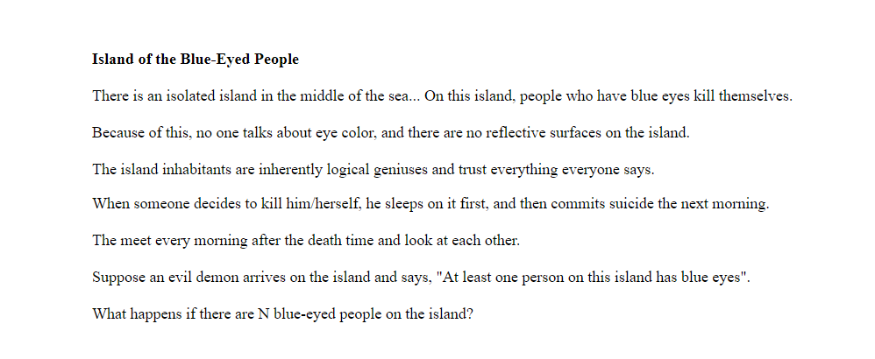

4. Give the complete URLs for three distinct sites that link to www.ci.beavercreek.oh.us. These sites must not include any from the beavercreek.oh.us domain.

* Google “link: [www.ci.beavercreek.oh.us](http://www.ci.beavercreek.oh.us) -site: www.ci.beavercreek.oh.us”

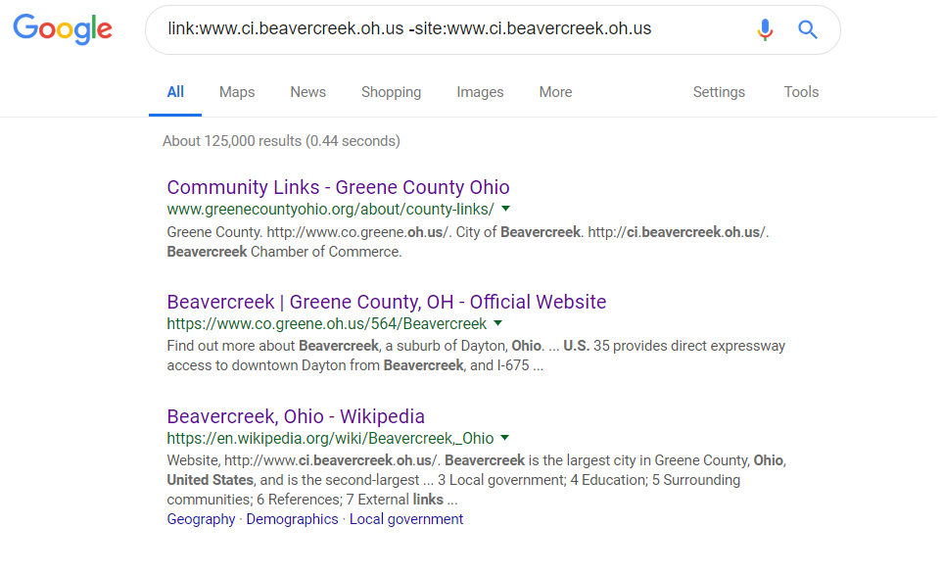

* Go to the Beavercreek, Ohio Wikipedia page <https://en.wikipedia.org/wiki/Beavercreek,_Ohio>
* Scroll down to the “External Links Section” and there is a link to the above website.

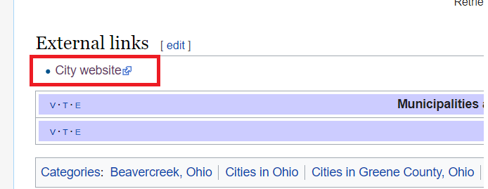

* Next hit is: <http://www.greenecountyohio.org/about/county-links/> and the link to the Beavercreek City website is linked to below and shown in the red box.

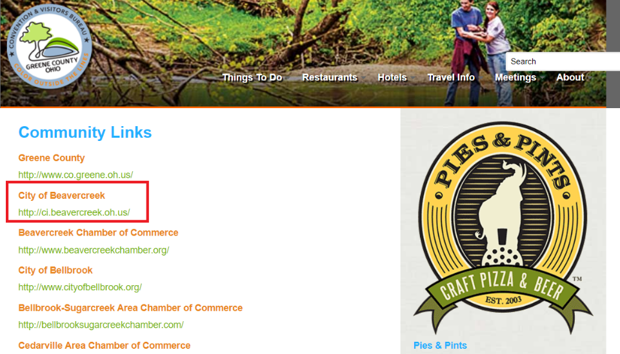

* Selecting the hit for the Greene County OH official website takes you to the Green County, OH website page on Beavercreek <https://www.co.greene.oh.us/564/Beavercreek> and the hyperlink in the red box links to the website for the city of Beavercreek as shown below

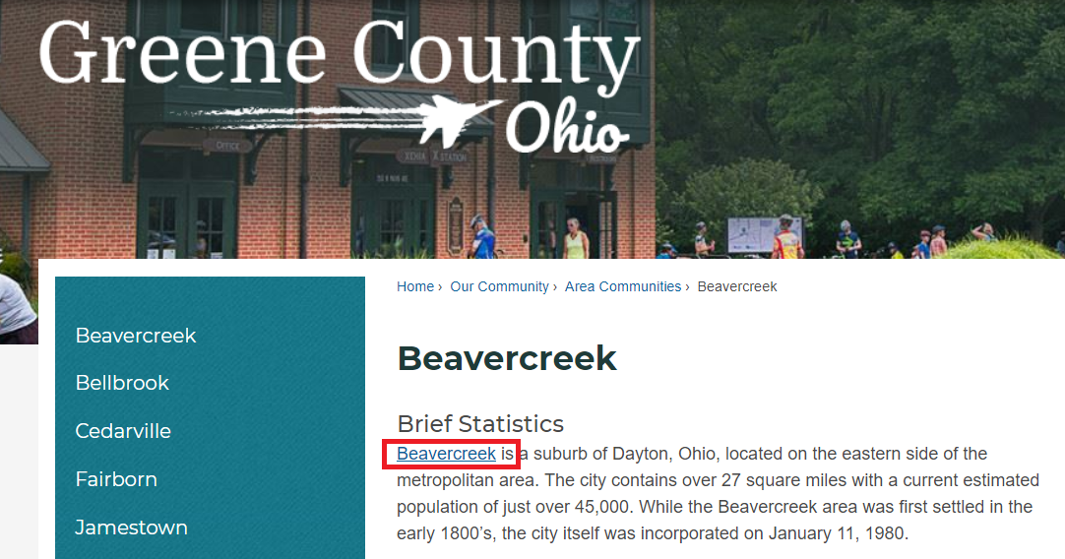

So the 3 URLs that link to the city website are

* <https://en.wikipedia.org/wiki/Beavercreek,_Ohio>
* <http://www.greenecountyohio.org/about/county-links/>
* <https://www.co.greene.oh.us/564/Beavercreek>

5. I like the Frank and Ernest cartoon. I really like the following .JPG image (without the annoying red text of course). Retrieve a copy of the file from http://www.cartoonistgroup.com/store/add.php?iid=18317. You must submit a screenshot of your browser clearly showing the file’s URL and the cartoon as shown below, except your screenshot will contain the

full URL. The only object in the browser window is the cartoon. Explain how you obtained your file. You must download from the www.cartoonistgroup.com site.



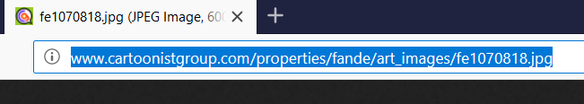

* Following the provided link takes you to the store page and mousing over the picture will display a no copy image. To get around this, do the following.
* Right click in the <http://www.cartoonistgroup.com/store/add.php?iid=18317> page and select “Inspect page source”
* Mouse over the code until the photo is highlighted as displayed below. Click the ellipsis inside the following “<p>” tags highlighted in the red box to expand the code

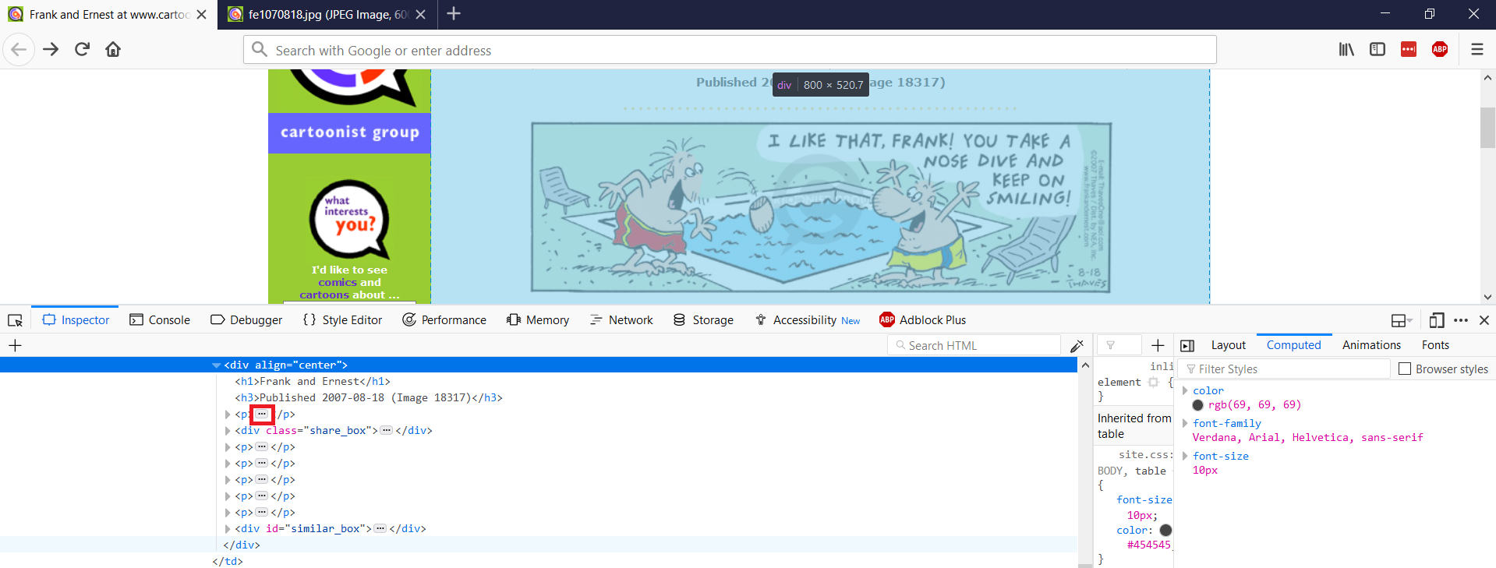

* Expanding all of the code blocks inside these “<p>” and “</p>” tags you will eventually expand the block highlighted in blue and red below.

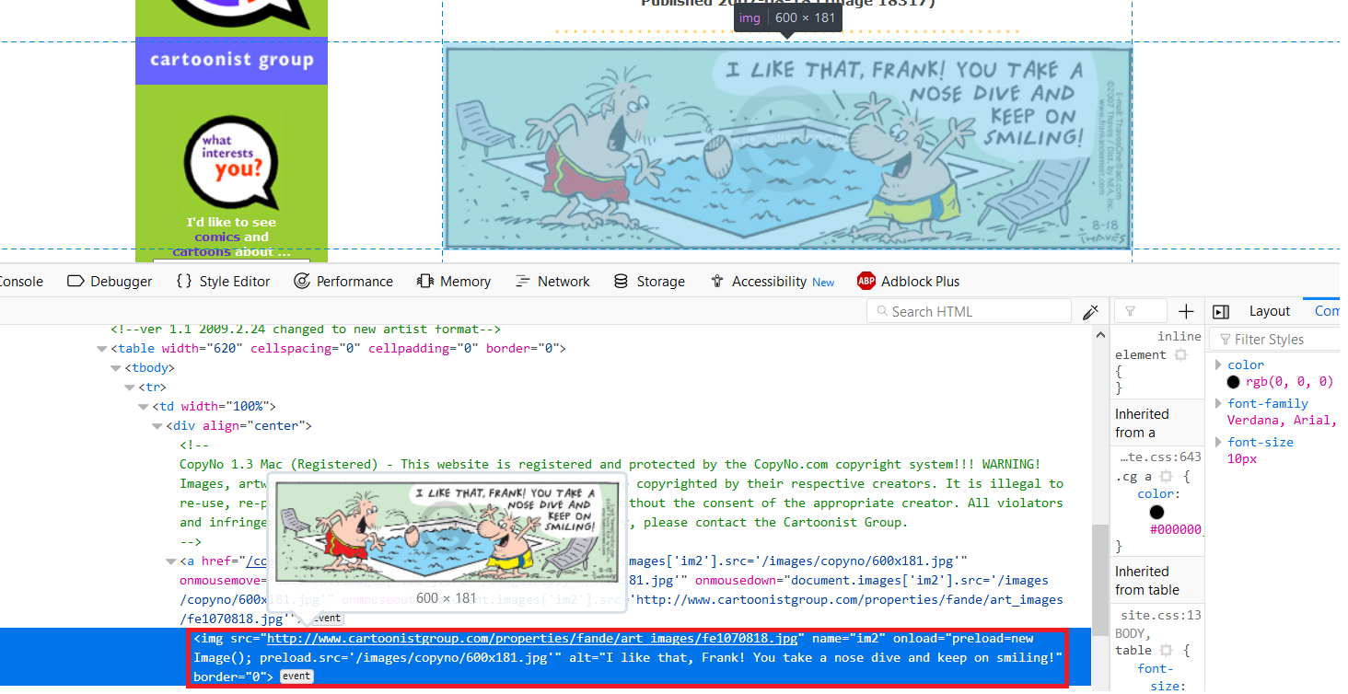

* Mousing over the link will provide a preview as shown in the screenshot above. Right-click this and select the “copy link address” option. Pasting the copied link into a browser will provide you with the page in the first screenshot of only the image.

6. Provide an image of the front and back of Ed Skoudis’ house. What full postal address, email address, and contact phone number would you use to tell him his sprinklers were left on all night?

* Google Ed Skoudis and go to his twitter page https://twitter.com/edskoudis?lang=en

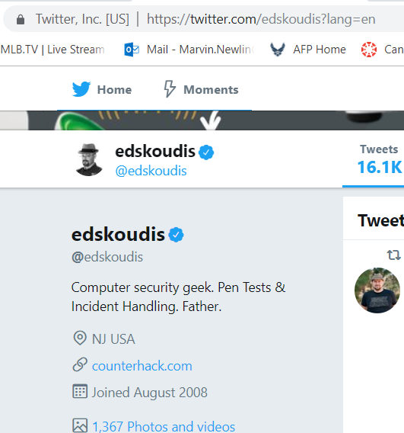

* From here we see that he lives in New Jersey
* Go to [www.whitepages.com](http://www.whitepages.com) and search for “Ed Skoudis NJ” and the following result appears

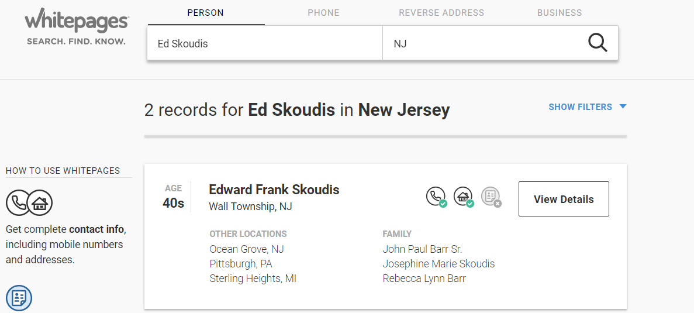

* Selecting “view details” gives us the following details

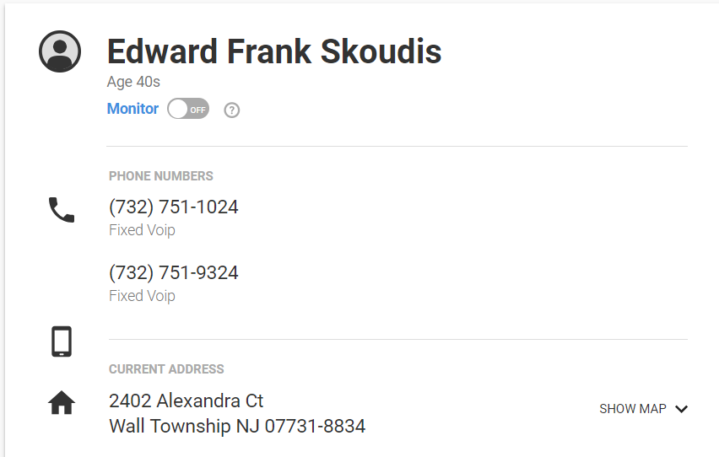

* Selecting the second phone number shows us that the number is indeed registered to Ed Skoudis

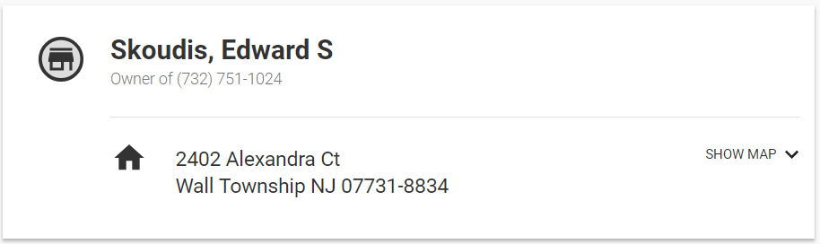

* Entering his address into Google Maps we get the following shots of his house. No Google Street View is available, so these shots use the 3D mode in Google Maps

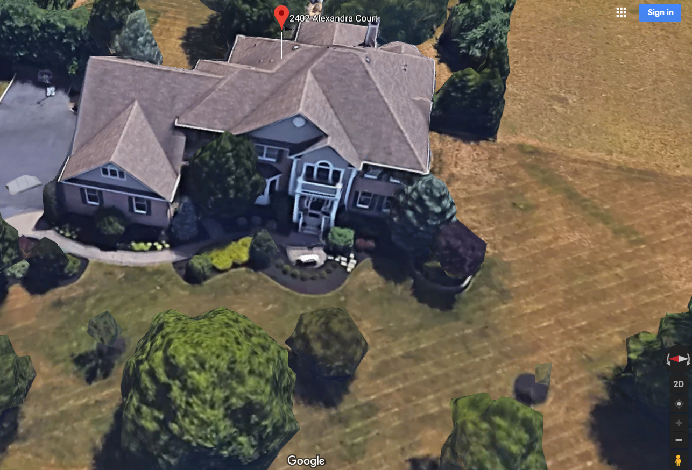

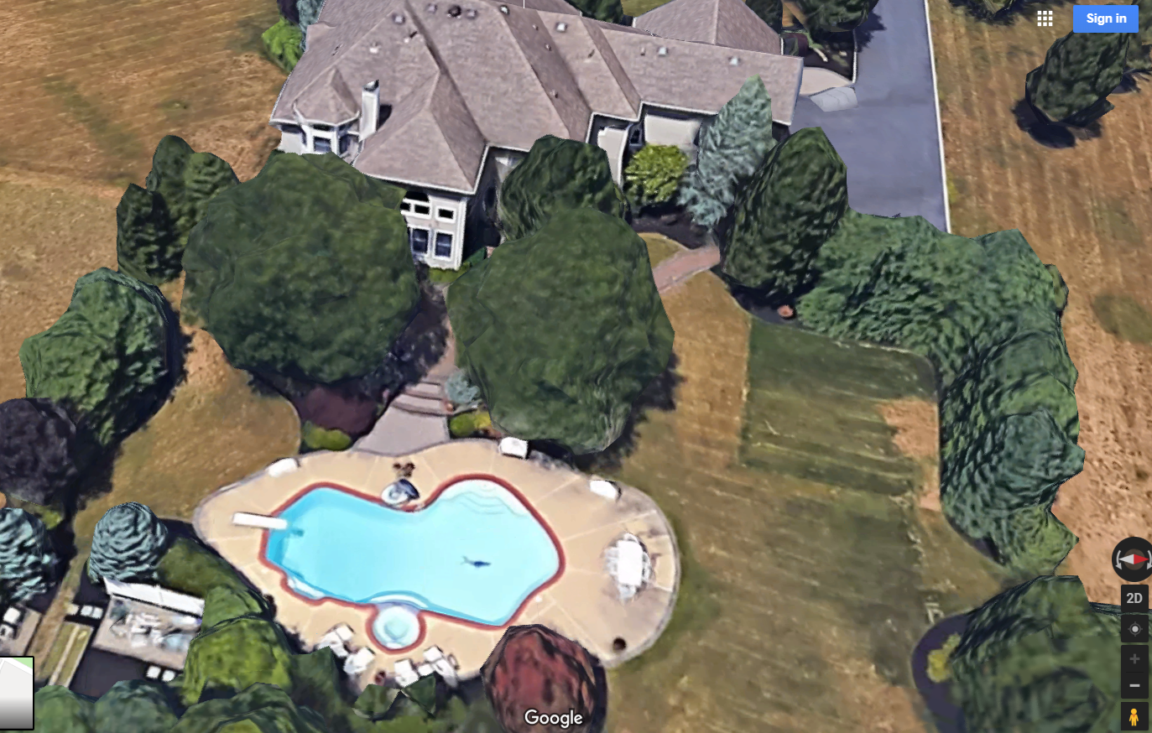

* To find his email address go to the Who Am I page on his website <http://www.counterhack.net/who_am_i_.html> and at the bottom right click and select “copy email address” in the linked email text shown in the red box below

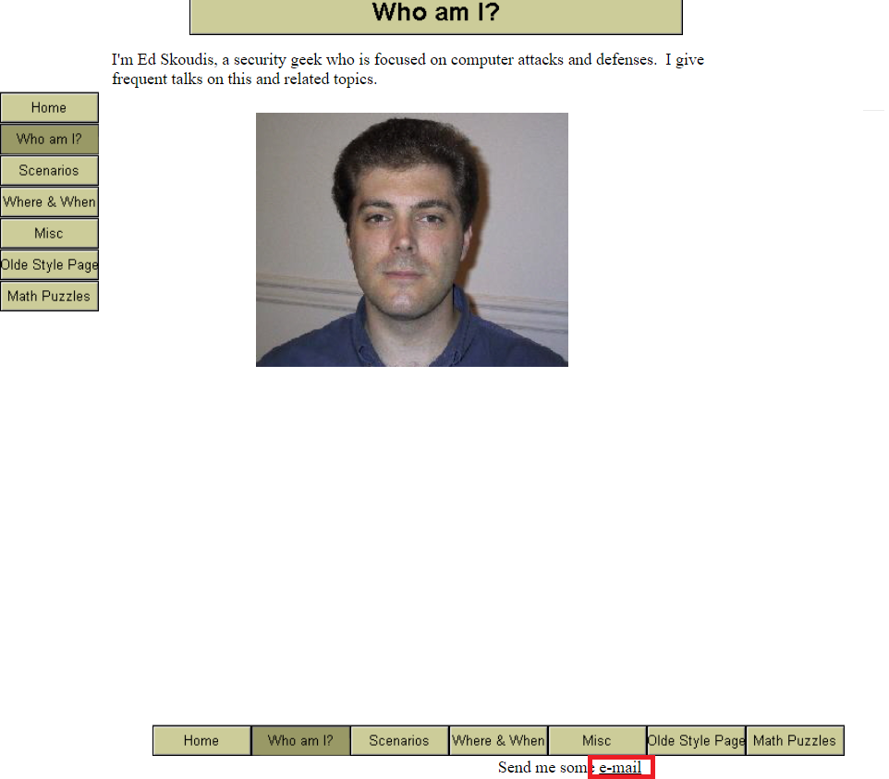

* Pasting the email address shows us that his email is: [edskoudis@yahoo.com](mailto:edskoudis@yahoo.com)
* Ed Skoudis full contact info
  + 2402 Alexandra Ct, Wall Township, NJ 07731-8834
  + (732) 751-1024
  + [edskoudis@yahoo.com](mailto:edskoudis@yahoo.com)

7. Watch the following found in the Resources directory:

a. History of hacking video (also at <https://www.youtube.com/watch?v=Y47m1cOyKjA>)

* Watched

b. Recon video: “Watch hackers break into the US power grid.mp4”

* watched

c. Slideshow “Killing with Keyboards”

* Watched

d. Short clip at http://www.aclu.org/pizza/images/screen.swf

Indicate in the answer section of this question that you actually watched all videos and presentations.

* Watched

**Part 2 - Working with Linux and gcc**

8. You will practice working with c programs in Linux for this problem.

1. In Linux (e.g., Kali), compile and run the following program called **Caesardecrypt.c**; this file is in the Lab1 directory. Hint: look up the **gcc** command.

* To compile the program we enter “gcc –o Caeserdecrypt Caesardecrypt.c”

1. Provide a screenshot showing the successful compilation.

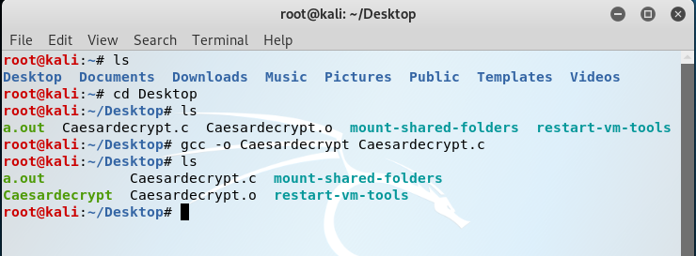

* Since we generated the Caesardecrypt file and Caesardecrypt.o object file, we know that the file was compiled successfully

1. Provide another screenshot showing the execution after you enter the following string as input: **FBEHUDWWDFNLVFRRO**.

* To execute, enter “./Caesardecrypt”

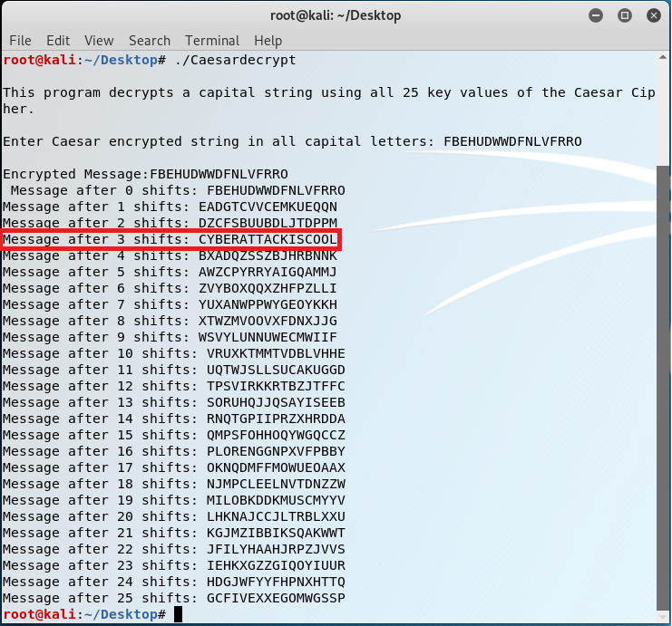

1. Finally, what was the original unencrypted message?

* As we can from the red box above, the original unencrypted message is “CYBERATTACKISCOOL”

**Part 3 - Interacting with Targets**

**You must be on the CDN network to connect to the targets.**

Part 3 requires you to connect to targets using various protocols. The targets are listed as B and C in the figure below; you are running Windows on machine A. The IP addresses are 10.1.0.63 (B) and 10.1.0.198 (C).

9. Working with SSH.

1. What transport protocol and port is the SSH server using?

* SSH operates on TCP port 22, the connection is displayed as a TCP connection on port 22 in the red box of the figure below b-3

1. Establish SSH session 1 from A to B using username of **user** and password of **Password!123**.
   1. I suggest the tool called Putty (putty.exe at <http://www.chiark.greenend.org.uk/~sgtatham/putty/>) as your SSH client. Putty will issue a warning asking if you trust the target; select “yes” to accept the target’s certificate. Putty will open a command window allowing you to execute commands on the target.
   2. Once connected, display the name of the target as well as the operating system type and version number of the computer you are accessing; provide a screenshot of this window.

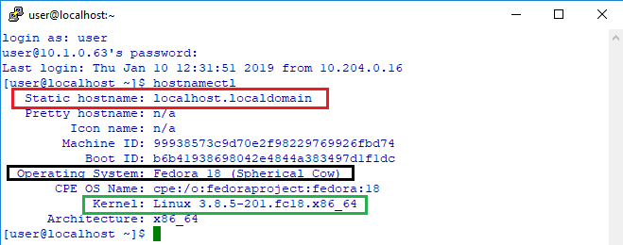

* + - In the red box above we can see that the hostname is localhost.localdomain
    - In the black box we can see that we are running Fedora 18 (Spherical Cow)
    - In the green box we can see that the version is Linux 3.8.5-201 x86
  1. Display the active TCP connections on B. Highlight your connection to the target?

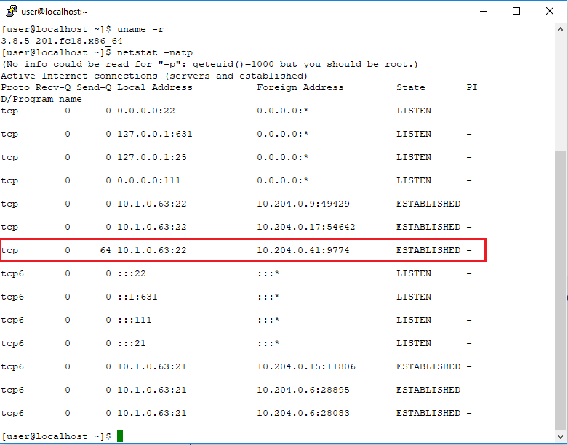

* My IP address is 10.204.0.41 so the connection I have is highlighted in red.
  1. Find a picture of a horse. How did you find the horse picture? Take note of the file’s location; you will download this file later. Hint: to suppress error messages like “Permission denied”, you can redirect error messages (i.e., 2) to the null device by including the following after your command: **2>/dev/null**

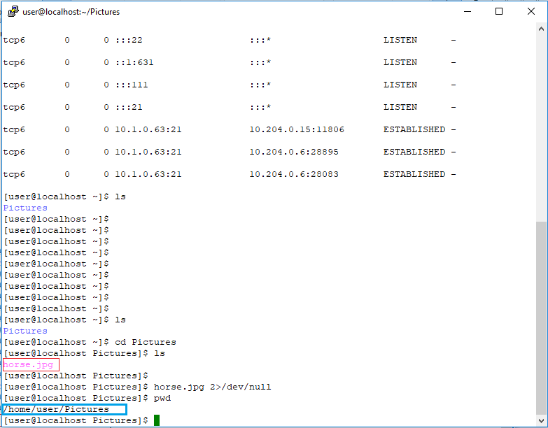

* Using the command “ls” displayed the Pictures folder
* Using the command “cd Pictures” changed the directory to the pictures folder
* Using “ls” again displays the “horse.jpg” file
* File location is “/home/user/Pictures/” as shown in the blue box

1. Within the same Putty window, ensure you can reach C from B using ping. Now type **ssh user**@<<C’s IP>> to establish SSH session 2 from B to C where **user** is the username. Use **Password!123** for the password.
   1. Accept C’s certificate. Once connected, display the name and operating system version of the computer you are accessing.

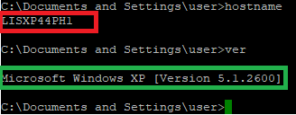

* As we can see from the red box, the hostname is LISXP44PH1
* The green box shows us the system is running Windows XP Version 5.1.2600
  1. Find a file on C that has a filename with the format **flag?.\*** where ? is a number and * could be any extension. Hint: files with “.lnk” extensions are only links. Remember to start your search from the \ directory. Take note of the file’s location; you will download this file later.

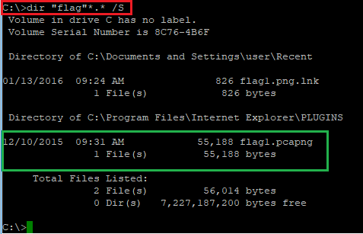

* + To find the file we search from the root directory using the following command: “dir “flag”*.* /S” as shown in the red box
  + In the green box we see the file listed as flag1.pcapng and its location is C:\Program Files\Internet Explorer\PLUGINS

1. Now type **exit** at the command prompt while logged into C to tear down SSH session 2. You should see your Linux command prompt return meaning you are now interacting with B. Once again, type **exit** to tear down SSH session 1; this will close the Putty window.

10. Using FTP, transfer the horse picture to your machine. You must use the native (command line) Windows FTP command. Provide a screenshot of the FTP window showing your successful FTP session including file download. What transport protocol and port is the FTP server using? Are you using active or passive FTP? How can you tell? What port numbers are the client and server using? What is the name of the horse? Filtered Wireshark screenshots are required.

* The below screenshot shows the entire FTP exchange. The red box shows the pertinent lines that say the file transfer was successful. The screenshot with the green box shows the actual file in the file explorer on my machine

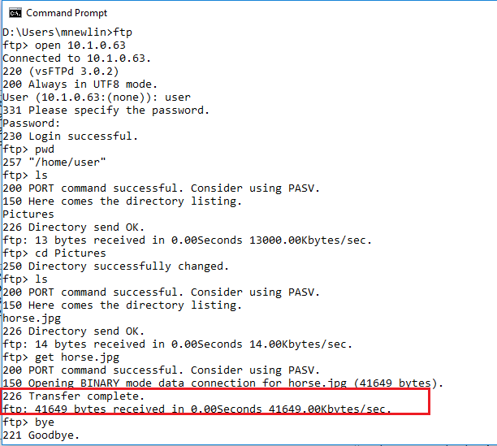

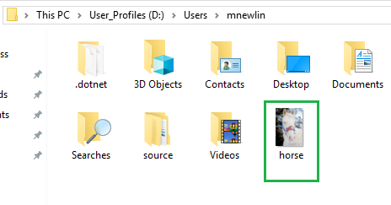

* As we can see below in the red box, the FTP server is running on TCP port 21.
* We can see in the red box below, the control channel is on port 21, and in the green box below, data is sent via port 20 from the FTP server. This is a giveaway that we are using Active FTP since if we were using passive FTP the data connection would be coming from some other random port other than port 20.
* For control channel, the client port is 3162 (red box below) and for the data channel, the client point is 3165 (green box below)
* For control channel, the server port is 21 (red box below) and for the data channel, the client point is 20 (green box below)

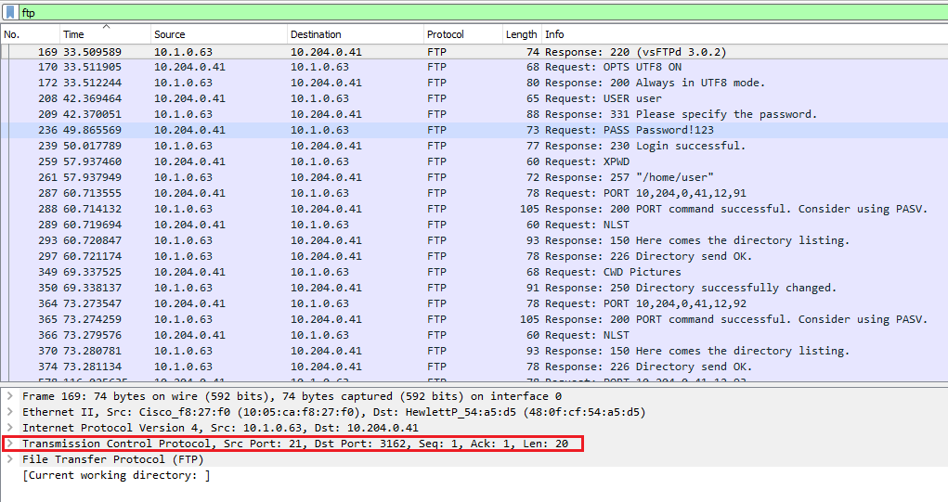

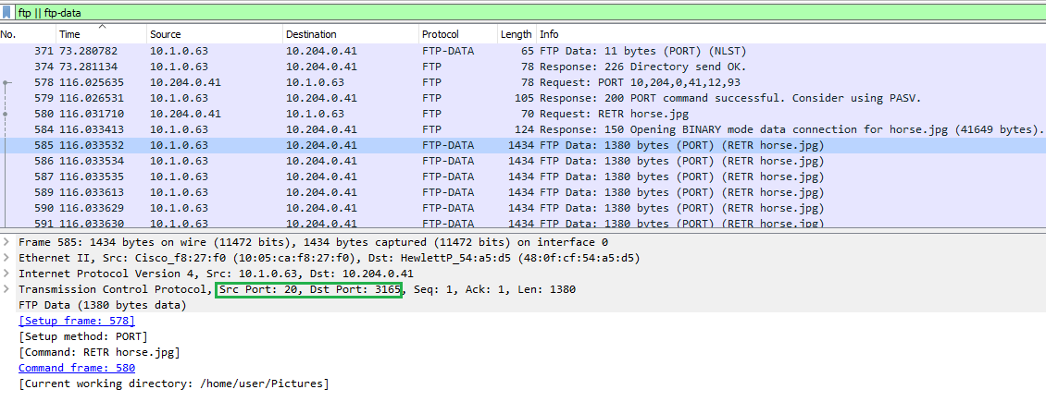

11. Using SCP or WinSCP (<http://winscp.net/eng/download.php>), transfer the flag file to your machine. If SCP does not connect to the target, try SFTP. Provide a screenshot of the [Win]SCP window showing successful file download and another screenshot of the image contained in the flag file. Describe exactly how you learned the contents of the flag file and displayed the image; screenshots are a must as you describe your process.

* In the green box below we see the flag1.pcapng file located in my documents folder.
* As indicated by the type section and file extension this is a wireshark capture file

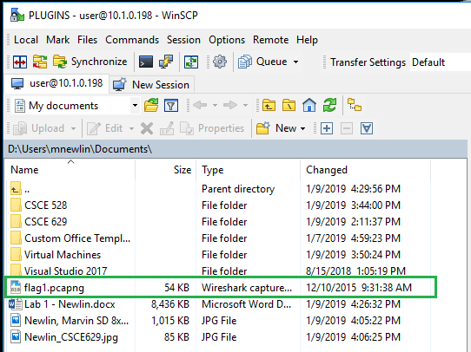

* Opening the file in Wireshark we see that there is an HTTP GET request (green box below)

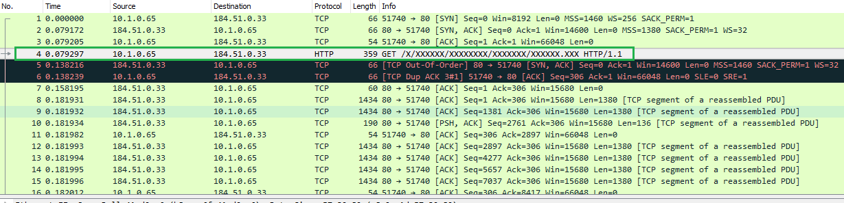

* Inspecting the contents we the request is for the URL (red box below) <http://a.espncdn.com/X/XXXXXX/XXXXXXXX/XXXXXXX/XXXXXX.XXX>

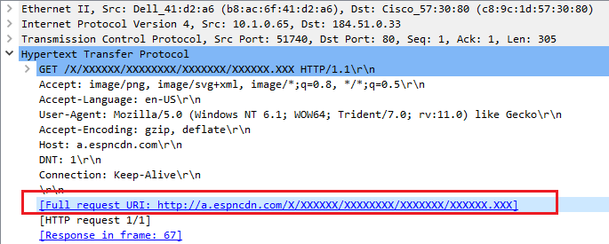

* In the response frame we see that the requested image is actually an object, a PNG file specifically. (Red Box below)



* Inside the Wireshark capture select “File > Export Objects > HTTP” This will display the following window

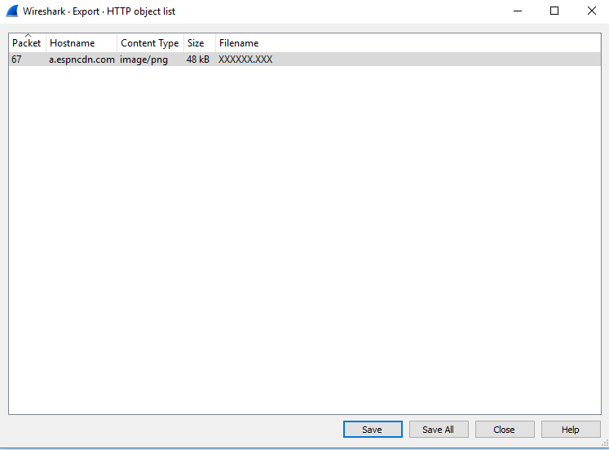

* Select the only available option and click “Save”.

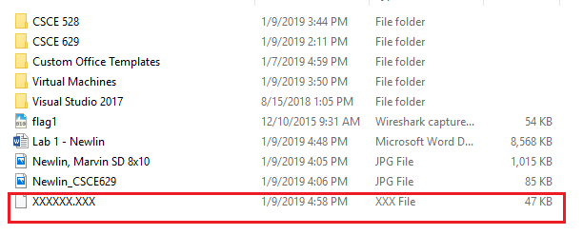

* Once saved, change the extension of the file from “.xxx” to “.png” (red box above) and open the file with your favorite PNG viewer to reveal the following photo of the stadium seating chart for the superdome

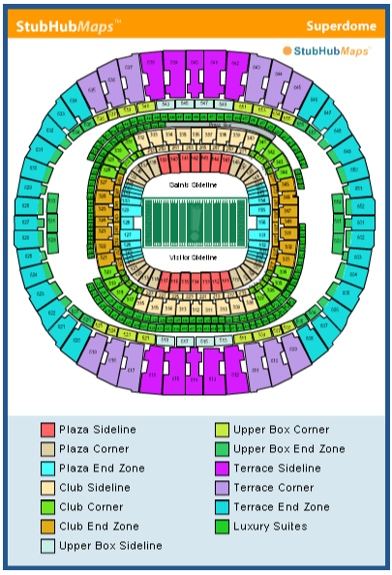

12. Now upload an interesting photograph of yourself to machine C in the “**Documents and Settings/user/My Documents**” folder. Ensure your file name starts with your last name (e.g., Smith.jpg) and your face is clearly visible.

* Uploaded picture to the above folder (red box below)

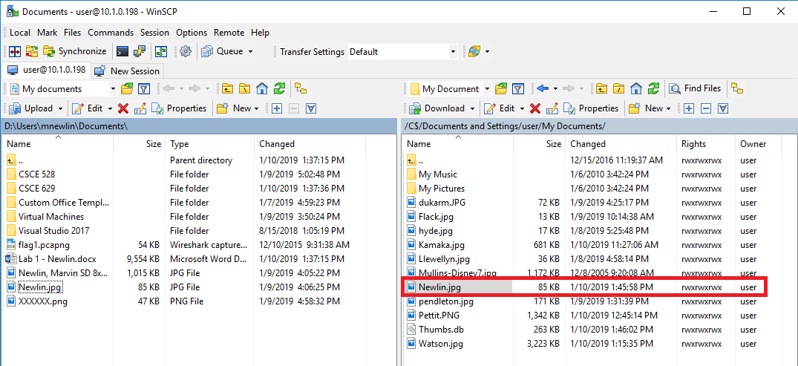

13. Using Remote Desktop Protocol (RDP), connect to the machine called RDP# where # is your team number. Provide screenshots of the windows/commands used. What transport protocol and port is the RDP server using? Provide a Wireshark screenshot of your computer using the protocol and port listed; filter your Wireshark capture to only include frames involved. What is the secret message found on the target (filename contains “secret”)?

* RDP uses TCP port 3389 and we can see the traffic displayed in wireshark with the filter “tcp.port == 3389”

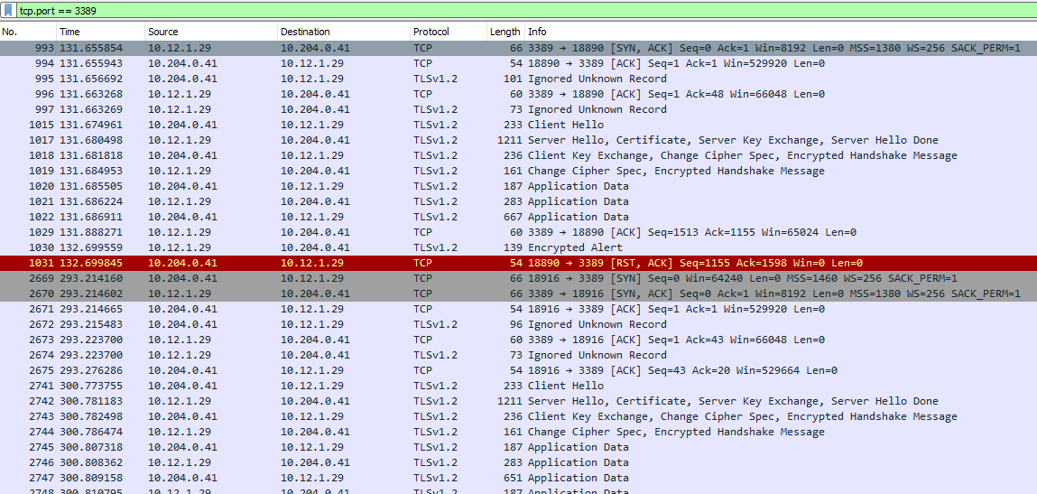

* Additionally, inspecting one of the packets, we see that we are indeed using TCP port 3389 for the RDP traffic (red box) and it is being encrypted with SSL (green box)

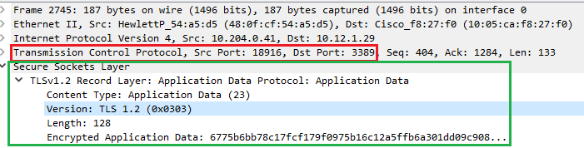

* Open up the RDP client on a windows machine by typing “mstsc /console” from the command line
* 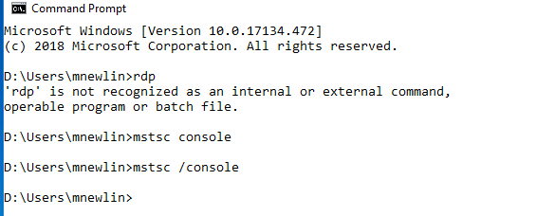
* The following window appears

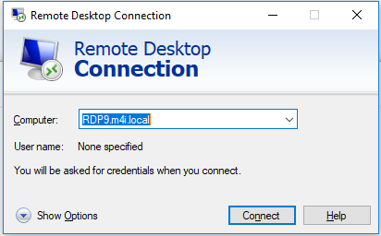

* Enter RDP9.m4i.local
* Click “Show options”
* Enter “user” as the username and “Password!123” as the password
* This will display the windows screen as displayed below

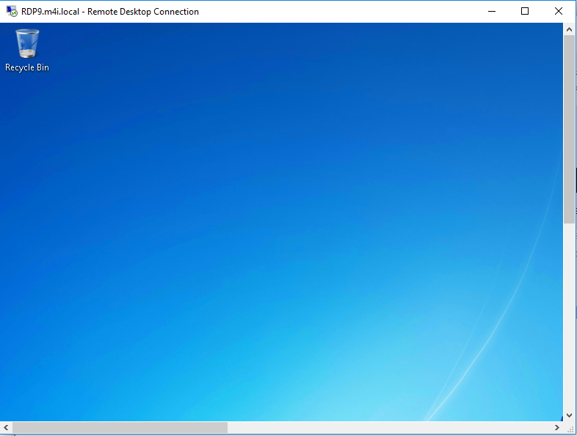

* Open file explorer and go to the C:/ drive and in the search bar enter “*secret*” this will display the following results
* Open the file in the red box above titled “Soopersecret” and it will display the following results

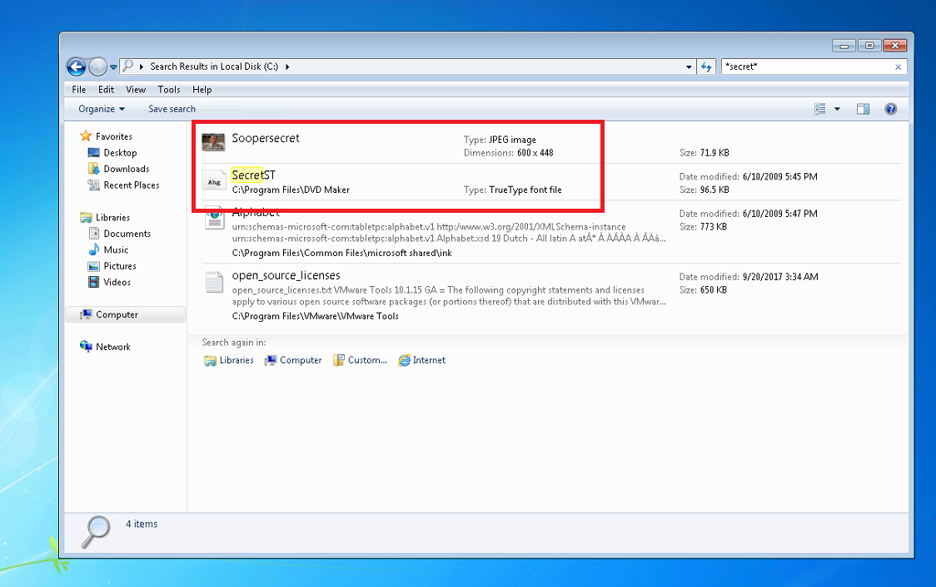

* As we can see there are two files with the word “secret” in the name. Opening the first one titled “Soopersecret” we find the below picture

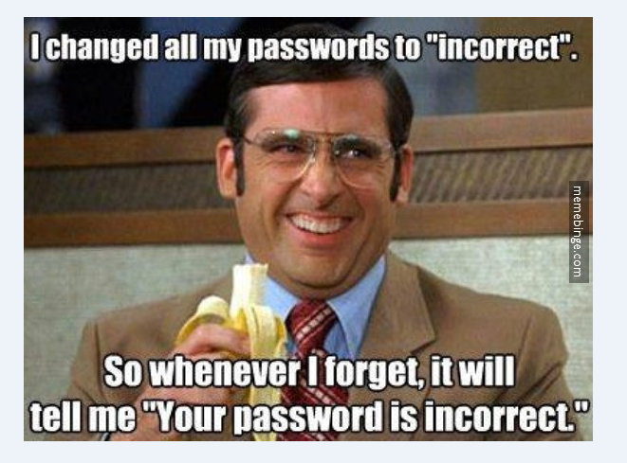

* The secret is that all the passwords are “incorrect”
* Opening the second file “SecretST” we get the following

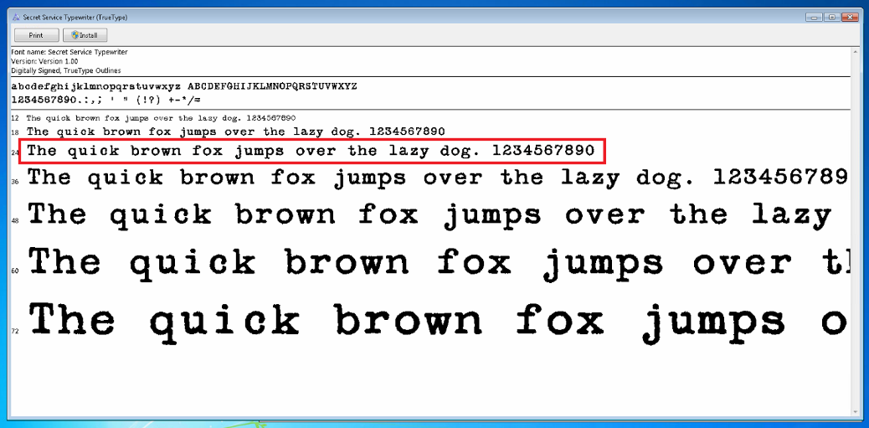

* Here we see that the secret message is “The quick brown fox jumped over the lazy dog. 1234567890”

**General Observations**

**These questions must also be answered and count towards your score.**

How long did it take you to complete Part 1 of the lab?

* 3 Hours including videos

How long did it take you to complete Part 2 of the lab?

* 20 minutes

How long did it take you to complete Part 3 of the lab?

* 3 hours

Was it an appropriate length lab?

* Yes

What corrections and or improvements do you suggest for this lab? Please be very specific, and if you add new material, provide the exact wording and instructions you would give to future students in the new lab handout. You may cross out and edit the text of the lab on previous pages to make minor corrections/suggestions.

* None